

School of Computing
and
Digital Technologies

Software Projects
(SEM2 AF-2025/6)
Group Project: Elanco - Tick Sighting Visualiser

Name | ID | Degree Route
Anini Pandiyan Sathya | 34011830 | BSc Computer Science
Rachel Kirtland | 35024542 | BSc Computer Science
Sia Pugal | 35058028 | BSc Computer Science
Andrei Pana | 35009488 | BSc Computer Science

Table of Contents

1. Client Background
2. Requirements Gathering Stage
2.1 Project Description and Users
2.2 User Stories and Acceptance Tests
3. Design Stage
3.1 Entity Relationship Diagram
3.2 Mockplus Prototype
3.3 Use-Case Diagram
4. Software and Its Presentation
4.1 The Production-Quality Software
4.2 Video Presentation
5. Evaluative Report on Legal, Social, Ethical and Professional Issues
5.1 Relevant Issues
5.2 Discussion
6. Evidence of Collaborative Work and Formative Feedback
6.1 Evidence of Collaborative Work
6.2 Incorporation of Formative Feedback
7. Use of AI declaration
8. References
Appendix
Peer Marking:

1. Client Background
A global leader in animal health, they provide innovative solutions to improve animal health and wellbeing. They proposed to develop a methodology for the effective visualisation of tick sighting data across the UK, contributing to public health awareness and animal welfare initiatives.

2. Requirements Gathering Stage

2.1 Project Description and Users
Users:
Name | Description
Admin | Super users who have all access to the system's features can also modify it.
Public | Only has access to the base features.

2.2 User Stories and Acceptance Tests
ID | User Story | Notes | Acceptance Test
A-US-1 | As an admin  I want to be able to login to the system  so that I can access the tick sighting database and modify its content. | This story assumes an admin account has already been created. | - Given the admin is on the login page, when they enter a matching username and password, then they should be successfully logged in.  - Given the admin is on the login page, when they enter an incorrect username or password, then they should not be successfully logged in.  - Given the admin is on the login page, when they do not fill either one of the textboxes, then they should not be successfully logged in.
A-US-2 | As an admin  I want to be able to create another admin account  so that the website can be managed by multiple admins. | This story assumes an admin user is logged in. | - Given the admin is on the create new admin page, when they enter valid credentials, then a new admin account should be created  - Given the admin user is on the create new admin user page, when they enter invalid credentials, then a new account should not be created.  - Given the admin is on the create new admin page, when they do not fill either one of the textboxes, then a new account should not be created.
A-US-3 | As an admin  I want to be able to add data into the tick sighting database  so that new sightings can be added to it. | N/A | - Given the admin enters new information into the textboxes, when it is submitted, then the tick sighting database should be updated.  - Given the admin enters invalid data into the textboxes, when it is submitted, then the tick sighting database should not be updated.  - Given the admin enters repeated data into the textboxes, when it is submitted, then the tick sighting database should not be updated.
A-US-4 | As an admin  I want to be able to delete values from the tick sighting database  so that redundant data can be removed. | N/A | - Given an existing value is selected, when the user clicks delete, then the value should be deleted from the tick sighting database.  - Given an invalid value is selected, when the user clicks delete, then nothing should be deleted from the database.
A-US-5 | As an admin  I want to be able to modify existing data in the tick sighting database  so that data can be kept up to date. | N/A | - Given the admin selects an existing value , when new data is entered, then the database should be updated.  - Given the admin enters an invalid value, when they try to update the record, then the database shouldn't be updated.
A-US-6 | As an Admin  I want to access the entire tick sighting database  so that I can see all the modified data | N/A | - Given the admin is on the view dataset page, when they click on display data, then they should be able to view the entire dataset.  - Given the user is not an admin, when they try to view the entire dataset, then they should be denied access
P-US-1 | As a public user  I want to be able to zoom in and see the tick distribution map  so that I can get clear insights from that. | N/A | - Given the member of the public is on the dashboard page, when they click the show map button, then the map should be displayed.  - Given the user is on the map page, when they try to zoom in on the map, then the map should be magnified.  - Given the user accesses the map, when they try to alter the details of the map, then they should not be able to change any information
P-US-2 | As a public user  I want to get an insight into tick sightings across the uk  so that I can see their whole impact on the UK. | N/A | - Given the member of the public is on the home page, when they click the want more info, then important info and images of individual ticks should be provided.  - Given the user is on the insights page when they try to load information about a tick in the UK, then it should be loaded from the database.  - GIven the user is on the insights page, when they try to edit information about ticks outside the UK, nothing should happen
P-US-3 | As a public user  I want to access visualised yearly trends in data  so that I can better infer what/where the current tick activity is | N/A | - Given the member of the public is on the home page when they click the yearly trends button, then the yearly trends should be displayed.  - Given the user has expanded the graphs,when they click order by year, then the trends for that year should be shown.  - Given the user has chosen what year to order the data by, when they choose a year with no data, then nothing should be displayed for that year.
P-US-4 | As a public user  I want to be able to assess national risk levels  so that I can know how my region is affected by ticks | N/A | - Given the member of the public is on the home page, when they click the national risk levels button, then a model of national risk levels should be displayed.  - Given the user is on the national risk levels page, when they enter a valid region, then data about it should be displayed.  - Given the user is on the national risk levels page, when they enter an invalid valid region, then nothing should be dispalyed.
P-US-5 | As a public user  I want to contact site support  So that I can clear up any misunderstandings | N/A | - Given the user is on the home page ,when they click on the contact button, then contact details of staff should be displayed.  - Given the user is on the contact page, when they click on the about us section then they should be taken to the official Elanco website.  - Given the user is on the contact page, when they click on the login to your account button then they should be taken to the login page.  - Given the user is on the contact page, when they click on the back to our dashboard button then they should be taken to the dashboard page.
P-US-6 | As a public user  I want to search for a city, region or species  So that I can find information that applies to my specific needs | N/A | - Given the user has clicked on the search bar on the home page, when they enter a city/region or species then information about it should be displayed.  - Given the has clicked on the search bar on the home page, when they enter an invalid city/region or species then nothing should be displayed.

3. Design Stage

3.1 Entity Relationship Diagram

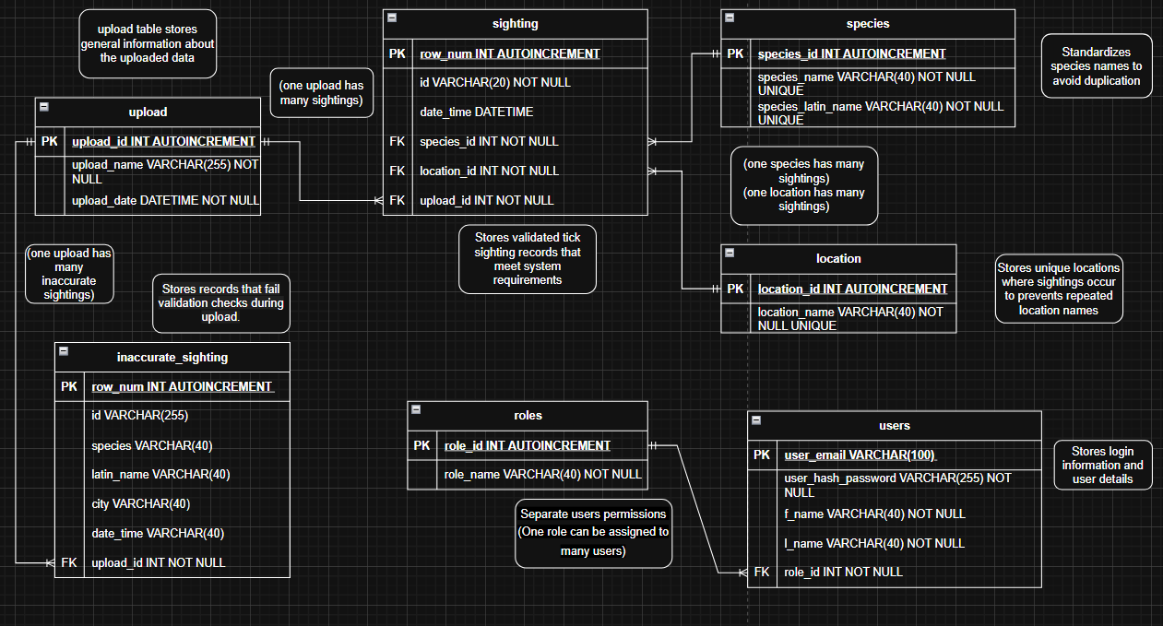

3.2 Mockplus Prototype
https://rp.mockplus.com/rps/7c_rOciIar/-OppAYtPz?
User Dashboard: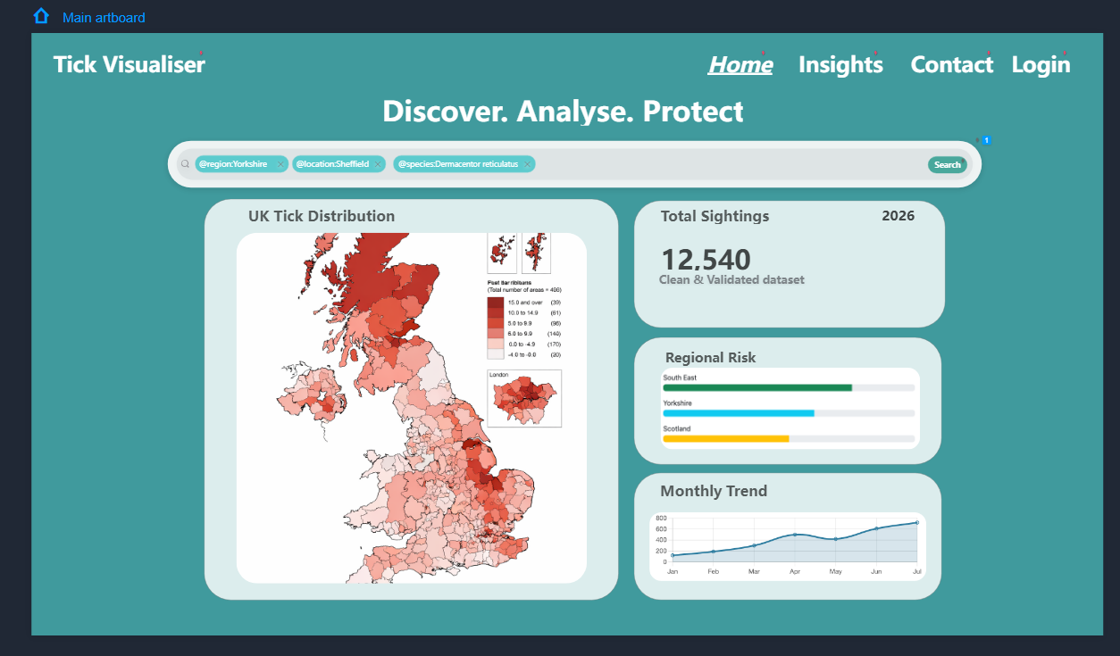
Admin Dashboard: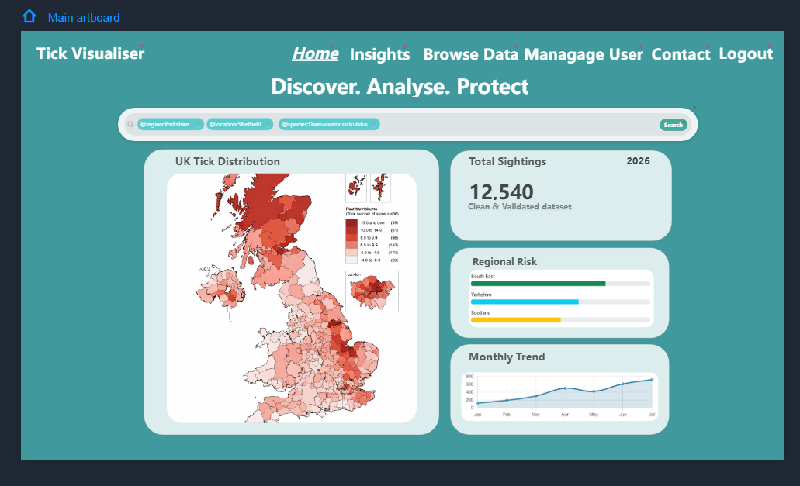

Insights Page: 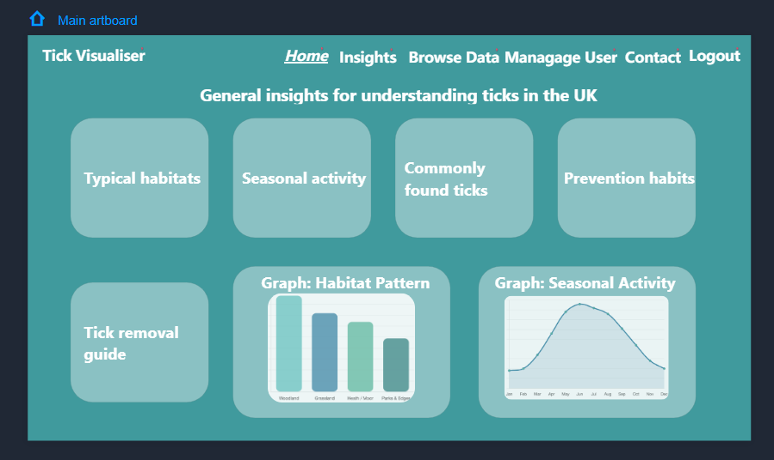

Manage User Page: 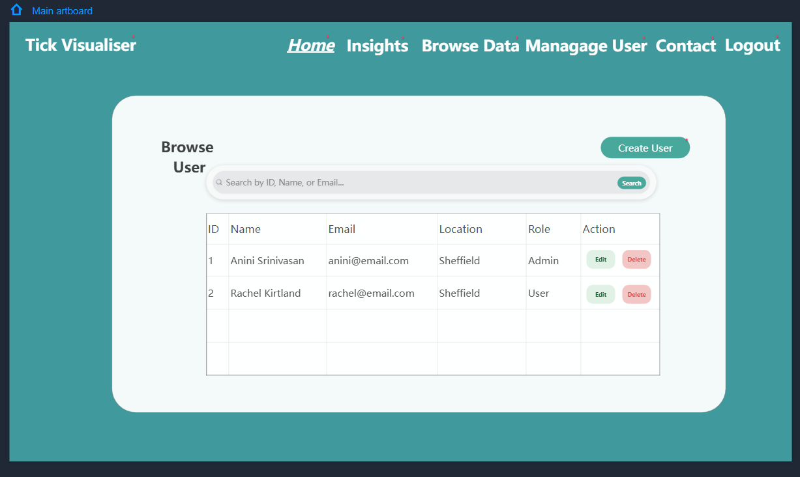

Manage Data Page: 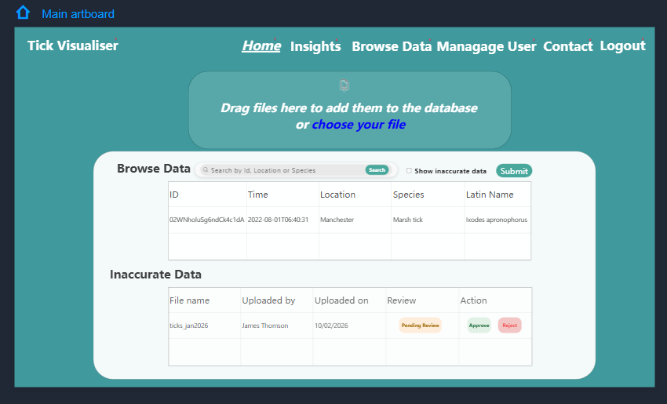

Contact Page: 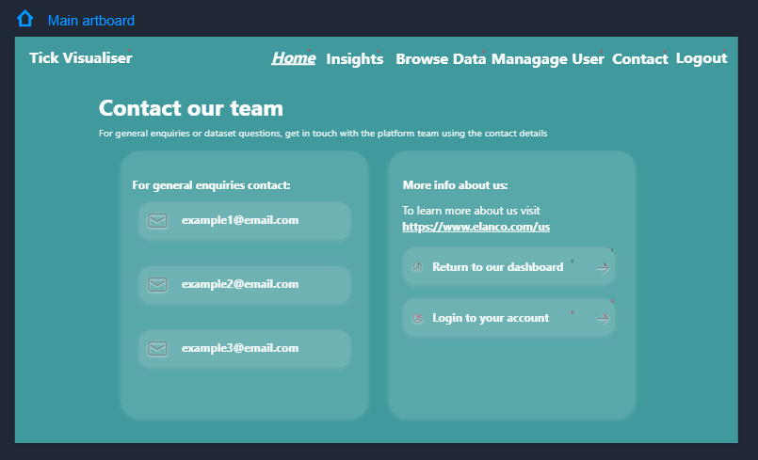

Login page: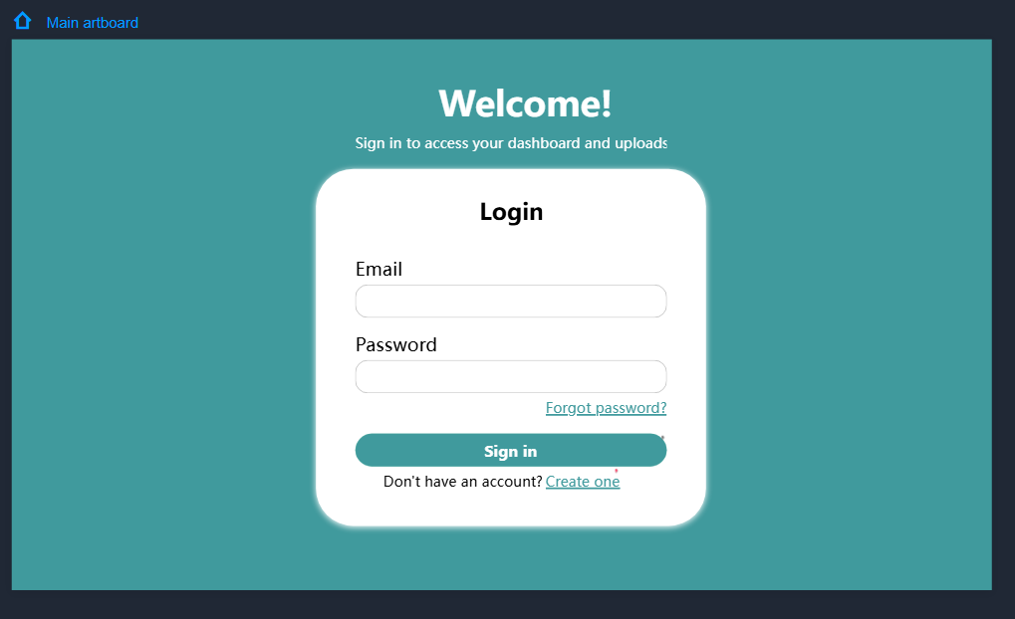

Register Page: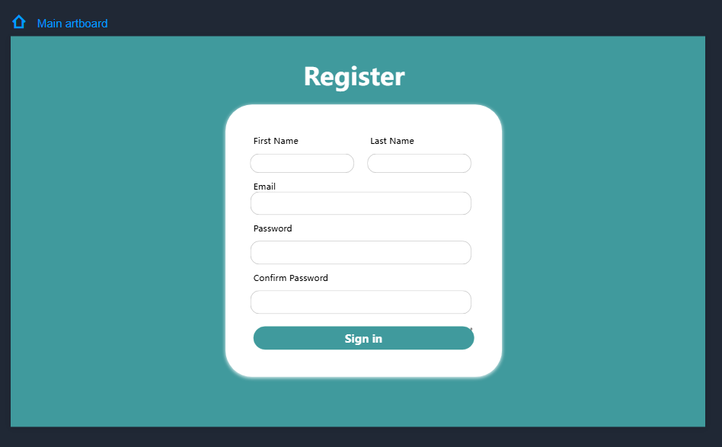

3.3 Use-Case Diagram
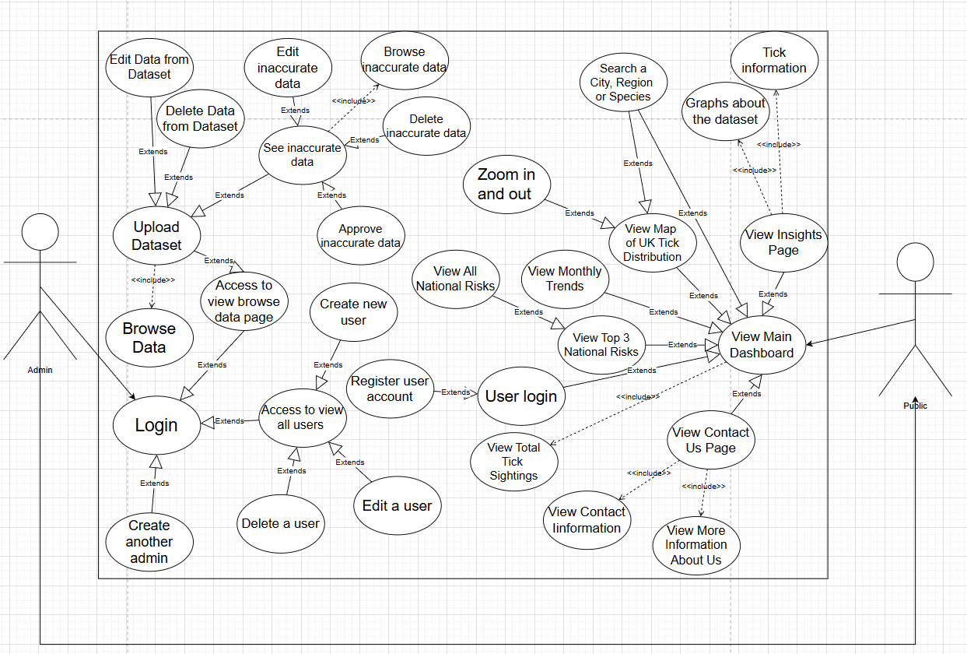

4. Software and Its Presentation

4.1 The Production-Quality Software
Submitted on blackboard

4.2 Video Presentation
https://shu.cloud.panopto.eu/Panopto/Pages/Viewer.aspx?id=d5fd9426-038d-4284-afae-b43500d1f6e9

5. Evaluative Report on Legal, Social, Ethical and Professional Issues

5.1 Relevant Issues

One legal issue of our project revolves around the storing and handling of user data. Since we collect a user's names and emails, we must make sure that this data is processed in a lawful and transparent manner; it must also be kept secure and not be displayed to the public.

A social issue our project faces is that a wide variety of people will need to use our website, including farmers and any pet owners. This means we must make our website widely accessible to many kinds of people and not require a user to have the latest hardware in order to use it; the information we display must be easily understandable.

Ethical issues revolve around our research of ticks and the information we display to the public. It is imperative that it is kept up to date in order to ensure that those who are looking for ways to deal with specific kinds of ticks can find the correct species that live in their specific area. It would also cause complications if users like farmers don't get the correct information about tick activity like when they are most active in order to make informed business decisions.

Professional issues we face include making sure that the employees linked in the contacts page are genuine experts and making sure the database is up to date with the correct data and is being maintained and updated. The finished website should follow the guideline the client has presented us and have no bugs or errors.

5.2 Discussion

In order to make sure we address these issues, when we make our program we must ensure that we make our project comply with legislation and relevant documents. The 2018 Data Protection Act states that the public users have “conferring rights on the data subject to obtain information about the processing of personal data and to require inaccurate personal data to be rectified”¹.We must protect a user's personal information and make sure admin users are the only ones capable of accessing and changing it to conform with this legislation. Accessibility issues were also a factor when designing our program as the ACM code of Ethics states “Technologies and practices should be as inclusive and accessible as possible”², we aimed to make it more available by designing our program with contrasting colours and ensuring that it fits on both a computer and mobile device, VS studio code also has built in speech reader features that we took advantage of. We must ensure that admins are the only ones who can edit the tick dataset in order to maintain the integrity of our data and they must be in charge of making sure it is completely accurate; this would also avoid any ethical issues revolving inaccuracies in data, as maintaining and updating the data would prevent any harm miscellaneous data would cause as the BSC code of conduct states programmers and admins should “have due regard for public health, privacy, security and wellbeing of others and the environment"³. Regarding professional issues we face we must make sure we strictly follow the guidelines laid out by the client and all inaccuracies in the dataset we work with have been rectified.

6. Evidence of Collaborative Work and Formative Feedback

6.1 Evidence of Collaborative Work
GitHub: https://github.com/AniniSrinivasan/tickvisualiser.git
Excel: Multiple tabs (weekly breakdown) - Link

6.2 Incorporation of Formative Feedback
Excel: Action Plan tab (screenshot below) - Link
Screenshots:
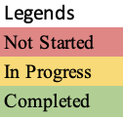
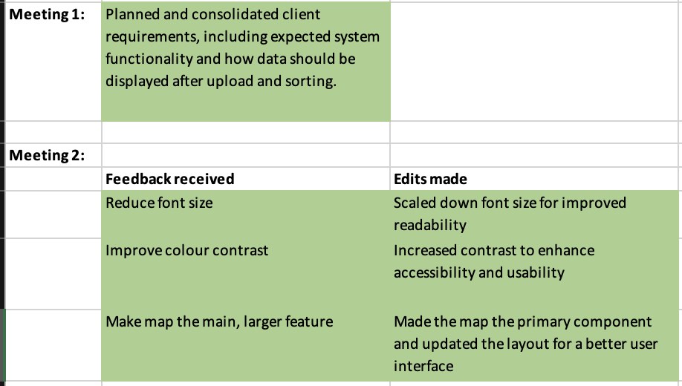 | 
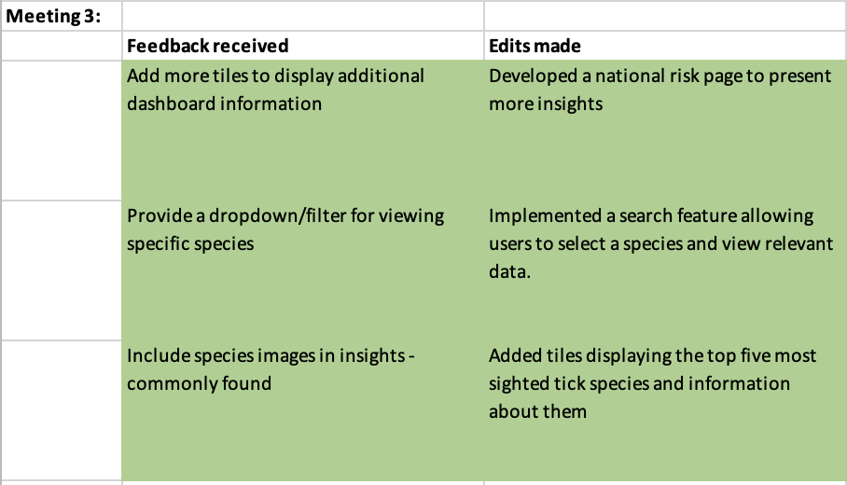 | 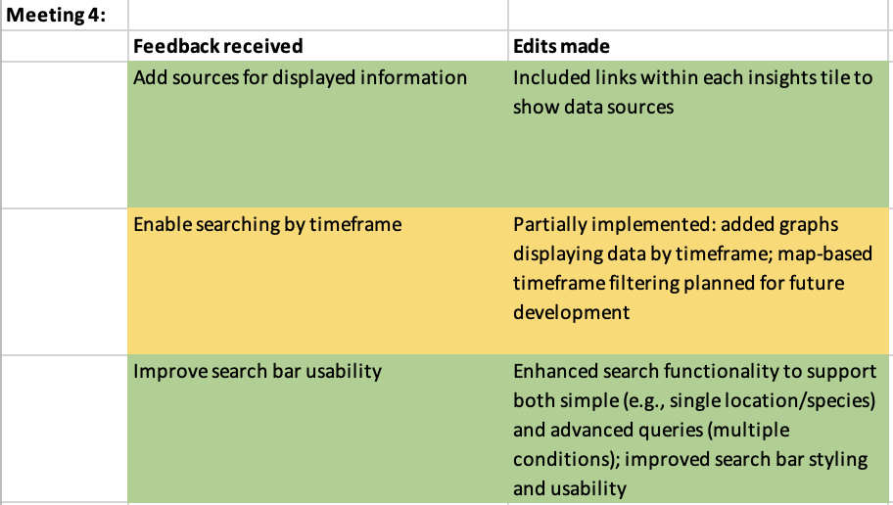

7. Use of AI declaration
Artificial Intelligence (AI) has not been used for any part of the activity.

8. References
- Data Protection Act, 2018, PART 1, Section 2, https://www.legislation.gov.uk/ukpga/2018/12/section/2/enacted
- ACM Code Of Ethics Section 1.4, https://www.acm.org/code-of-ethics
- BSC Code Of Conduct Section 1.1, https://www.bcs.org/membership-and-registrations/become-a-member/bcs-code-of-conduct/

Appendix

Peer Marking:
 | Team member + % coding + Portfolio | Mark out of 10
1 | Anini Pandiyan Sathya (60% coding) + MockPlus | 10/10
2 | Rachel Kirtland (18% coding) + ERD | 10/10
3 | Sia Pugal (12% coding)+ Use-case diagram | 9/10
4 | Andrei Pana (10% coding) + LSEPI, User stories and Acceptance testing | 9/10

 | Team member + work done
1 | Anini Pandiyan Sathya  Week 1:  Created GitHub repo, Excel sheets and shared them with the team for collaborative work, created Mockplus designs, prepared questions for the client meeting, developed basic static versions of webpages and shared them with the team, and contributed to use case diagrams and the portfolio.  Week 2:  Presented Mockplus designs in the client meeting and worked on the feedback, organised and assigned team tasks, continued working on dashboard.php and login.php, integrated bootstrap but later removed it, fixed the accessibility issues, structured and organised codebase and developed the browse-data.php page.  Week 3 :  Completed coding static versions of approve-data.php and browse-data.php, connected the project with the database, implemented some of the core functionalities in browse.php (upload file , data browsing, search, previous uploads), integrated the upload function with the database, fixed accessibility and SEO issues, and developed the edit/delete functionality.  Week 4:  Presented progress and gathered feedback and, researched on React vs AJAX, updated the database and fixed browse-data.php issues, started developing the AJAX version of browse-data.php and continued working on the database integration and map functionality.  Easter Break (Week 1 & 2):  Made changes to the database and ERD, improved the browse-data.php and fixed the graph issues since changes made to database broke the insights page, continued developing the AJAX version with edit features in browse-data.php, started and progressed on map in dashboard.php and worked on implementing and refining the search function.  Week 5:  Worked on overall CSS fixes and edit functionality, updated and finished contact.php and fixed the database issues related to login.php, improved search filter and started working on advanced search function.  Week 6:  Presented progress in the client meeting and gathered feedback, completed the advanced search function, made final touches across the project, made final updates to the portfolio, completed all my tasks and recorded a video for the technical demonstration and submitted the coursework.
2 | Rachel Kirtland  Week 1: Created and shared collaborative portfolio as well as document for collaborative notes and plans. Created the basic ERD and created and started working on the database.  Week 2: Continued work on the database based on client feedback and worked on catching the inaccurate data to be separated from accurate data.  Started work on insights page and details.  Week 3 : Continued work on insights page as well as updating the database and ERD naming conventions to be consistent and easier to read during coding.  Started working on dynamic graphs based on uploaded data file provided.  Week 4: Finished the static data needed for the insights page as well as the Monthly trend chart to display how many tick sightings per month.  Created separate navbars based on if the user is an admin or not and created the session needed for Sia to connect to login details.  Easter Break: Working on browse data inaccurate sighting button so when clicked it shows the inaccurate data and displays new button ‘Approve’  Week 5: Changed dashboard monthly trend chart to display the last 6 months data trend. Started and finished the browse data inaccurate data buttons such as edit in line, delete or approve data.  Week 6: Made slight changes to the insights page based on client meeting feedback such as adding reference links to tick info. Finished annotating the ERD and added to the portfolio. Added accessibility labels to code. Added screenshots of mockplus prototype to the portfolio.  Booked room to meet and record final video walk through. Record final video walkthrough. Final changes to portfolio.
3 | Sia Pugal  Week 1: Created discord group for main communication and completed 1st version of the use-case diagram and highlighted issues with some of the portfolio.  Week 2: Completed 1st version of contact.php and clarified some issues with the use-case diagram.  Week 3: Started working on register.php and finished css for contact.php and almost finished php for register.php.  Week 4: Figured out how to hash passwords, finished the 1st version of register.php and login.php and did some database editing for hashed passwords.  Easter Break: Finished admin-register.php and 1st version of regional-risk-levels.php and started linking the sessions based on the login.  Week 5: Tried to start protecting pages and displayed regional-risk-levels.php in descending order and displayed the top three on the dashboard and did some css for error messages on the login and register pages and finalised all the files I did.  Week 6: Fixed accessibility issues for the dashboard and regional-risk-levels.php completed protecting admin pages and fixed SEO issues and completed the final version of the use-case diagram with all the updated information and recorded the video.
4 | Andrei Pana  Week 1: Presented Questions in live meeting, started working on client types + user stories and acceptance tests  Week 2: Started working on LSEPI discussion and relevant issues and started researching examples relevant to our program, helped with mockplus prototype.  Week 3: started working on the manage user and total insights page, finished the initial prototypes  Week 4: continued work on manage user and finished total sightings + more research on relevant issues  Easter Break: reworded LSEPI discussion and finished research, edited total sightings to update with each upload  Week 5: Implemented total sightings into the dashboard page, worked on managing user edit function and completed delete function, and edited the SQL file added more negative acceptance stories.  Week 6: Finished LSEPI discussion and manage the user page, recording.

